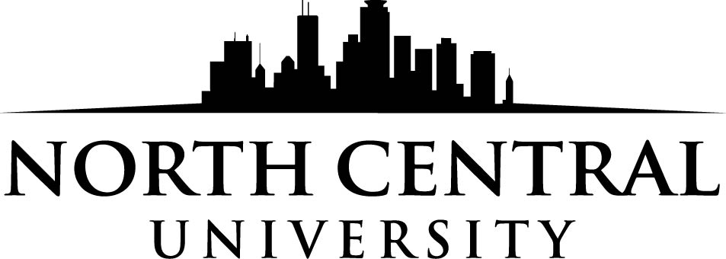

DYD/Outstanding Student Leadership
Scholarship Application
Fall 2019

Scholarship Application Instructions
Eligibility Requirements
- Applicant must be an active member of a local Assemblies of God church or youth ministry.
- Applicant must be enrolling as a first-time student at North Central University for the Fall 2019 semester.
- Applicant must meet NCU standard admissions requirements: cumulative high school GPA of 2.2 and an ACT score of 18 or above (or an SAT total score of 850 or above).

Application Instructions
- Applicants must complete the enclosed form.
- Applicants must provide a one-page essay that answers the following:
  - What is your current involvement with church and/or school?
  - Why do you want to attend North Central University?
  - Why should you be considered for this scholarship?
- Applicants must submit a recommendation letter from their youth leaders that answers the following questions:
  - What is the applicant’s involvement in your church and youth ministry?
  - Why is the applicant deserving of the scholarship?
Award Process
- Students will send their applications, recommendation letters, and essays to their district offices.
- The DYD will award up to two students a one-time $1,000 scholarship for North Central University by February 1, 2019.
- North Central will mail scholarship recipients a letter informing them of their scholarships.

Scholarship applications, personal essays, and pastor recommendation letters must be returned to the district office by February 1st, 2019.
Mail to:
New Jersey Youth Ministries
Attn: Scholarship
P.O. Box 100
Burlington, NJ 08016

DYD/Outstanding Leader Scholarship Application
Student Information
Student name:
Mailing address:
City:__________________________________________ State:______ Zip:
Email address:
Date of high school graduation:___________ Cell phone:

Church Information
Full name of home church:
Street address:
City:______________________________________ State: _________ Zip:
Church phone:
Name of pastor or youth pastor:

Please attach the one-page essay and recommendation letter to this form.

Applicant’s signature______________________________________ Date:

